**Councillors Pension Scheme – September 2021**

The NAC ran an Information Session on the Local Government Pension Scheme following their Members’ Meeting on 15 September 2021.



Ruth Benson from the NILGOSC delivered a presentation that was specifically designed for Councillors and covered the following:

* *An overview of the Local Government Pension Scheme for Councillors*
* *An explanation of the Annual Statement*
* *Questions and Answers*

A copy of the NILGOSC presentation can be viewed by clicking here>>

**Handling Online Abuse – June 2021**

Intimidation and abuse directed at councillors, particularly through social media, is a matter of concern for many of our members, therefore the NAC welcome the programme of work entitled ‘Civility in Public Life’ which is being carried out by the Local Government Association in co-ordination with WLGA, COSLA and NILGA.

Further details of this programme with advice and tips for elected representatives can be viewed on the LGA website by clicking the image below or visiting:

<https://www.local.gov.uk/our-support/guidance-and-resources/civility-public-life>

**Coronavirus COVID-19 Information – December 2020**

Links to websites with useful information and advice available in relation to COVID-19

**](https://www.health-ni.gov.uk/)

**Disruptieve Presentation – October 2019**

At the NAC 2019 AGM, guest speaker ANDREA WINDERS of DISRUPTIEVE provided a dynamic presentation on the Regeneration of Towns and Villages.  As an Urban Disruptor, Andrea shared her unique method for approaching failing areas, applying disruption, whether physical, digital, or other, and she gave details of a live project in the UK.

Andrea is available for discussions or meetings with councils, and she can be contacted by email at [andrea.winders@disruptieve.com](mailto:andrea.winders@disruptieve.com)

Please click here to view the Disruptieve presentation.

**Councillors exempt from paying GDPR Fees – April 2019**

There has been a change in legislation in relation to the payment of Data Collection fees for Councillors.

From 1st April 2019, Elected Members are exempt from paying an annual fee unless they operate from business premises that have a CCTV camera.

Councillors that are registered as a Data Collectors may receive, or have already received, a reminder to pay a renewal fee as these are being sent out by the ICO automatically, however this reminder can be ignored as fees paid will not be reimbursed by the ICO, if you have set up a direct debit to pay your fee you should cancel this.

See details overleaf which have been taken from the website of the

[Information Commissioners Office](https://ico.org.uk/), this information can be accessed by following this link –

<https://ico.org.uk/for-organisations/data-protection-fee/>

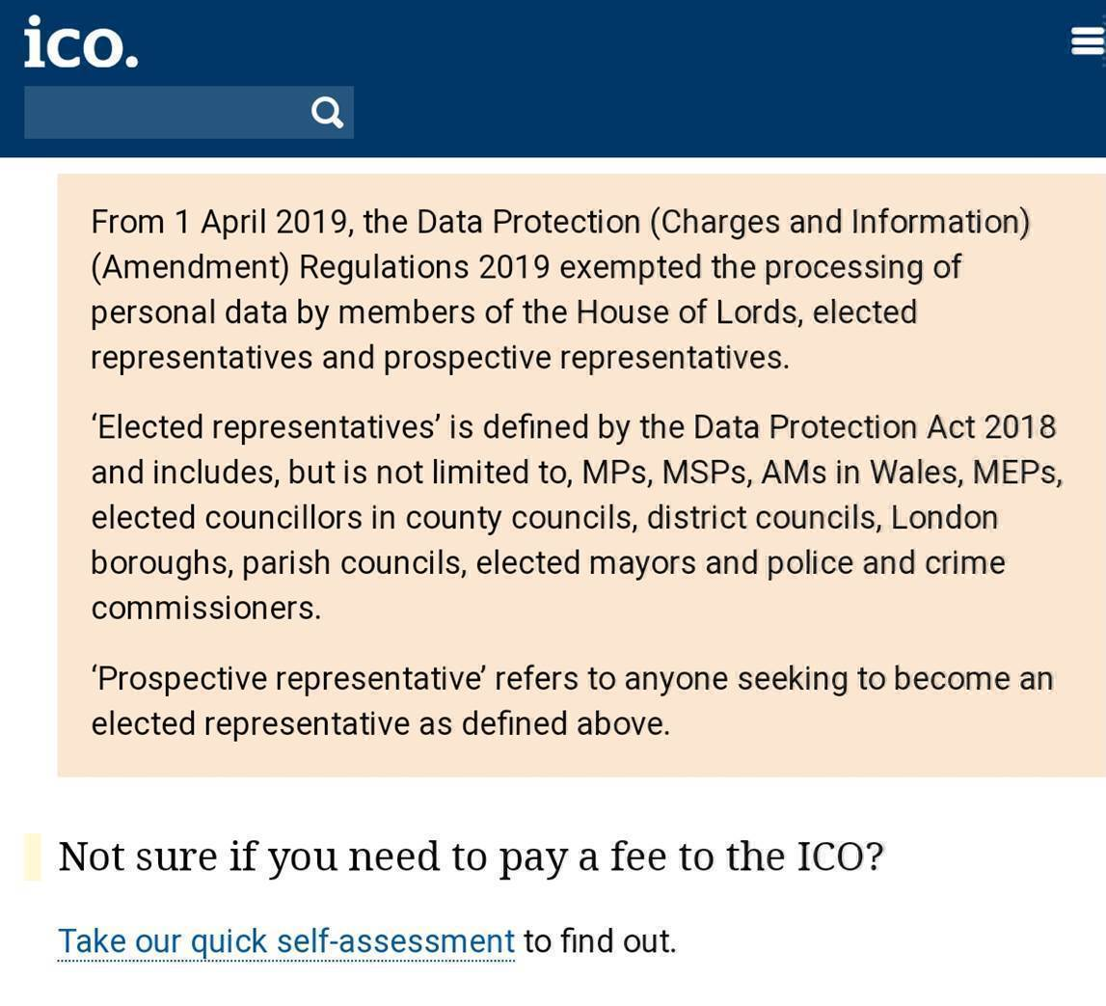

**Phasing Out Single Use Plastics Presentation – January 2019**

At the NAC Conference in January 2019 a presentation was made on Phasing Out Single Use plastics which can be viewed by clicking here>>

**Universal Credit – October 2018**

Advice NI made a presentation and prepared a Case Study Document for the National Association of Councillors, NI in October 2018. These documents cover many aspects of the Universal Credit scheme and highlight some of the problems that may be encountered by members of the public when making a claim. This information should be useful for councillors assisting constituents within their local communities with preparing applications and dealing with queries in relation to applications.

Click here for the [Universal Credit Presentation for NAC NI>>](http://www.nac-ni.org/index_htm_files/Universal%20Credit%20Presentation%202018%20to%20NAC%5b12117%5d.pdf)

Click here for the [Universal Credit Case Study for NAC NI>>](http://www.nac-ni.org/index_htm_files/Universal%20Credit%20Rates%20&%20Case%20Study%20NAC%202018.pdf)